For the attention of each member of CCVEC Teaching Staff
Re: Information Note – Requirement to be registered with the Teaching Council under Section 30 of the Teaching Council Act 2001

Section 30 of the Teaching Council Act, 2001 provides for a requirement that Teachers employed in recognised schools must be registered with the Teaching Council in order to be paid from Oireachtas funds. It is the intention of the Minister to commence section 30 during the 2012/2013 school year.
The enclosed document from Department of Education and Skills, PI_2012_001, provides important information for all members of Teaching Staff regarding the requirement to be registered with the Teaching Council and you are advised to pay particular attention to the contents. (NB: Please note that if you are currently employed as a Tutor on any programme, you are not currently required to be registered with the Teaching Council. Should this change, notification will be issued.)
Further information can be located on the Department of Education and Skills website, www.education.ie as follows:

- education personnel -> Payroll -> General Payroll Information
- education personnel -> post primary -> Pay
- education personnel -> teaching council

All queries regarding registration should be directed to the Teaching Council at the contacts set out in the enclosed document PI_2012_001.

General queries may be addressed to the Human Resources Department by email to recruit@corkvec.ie or Telephone 021/4273377.
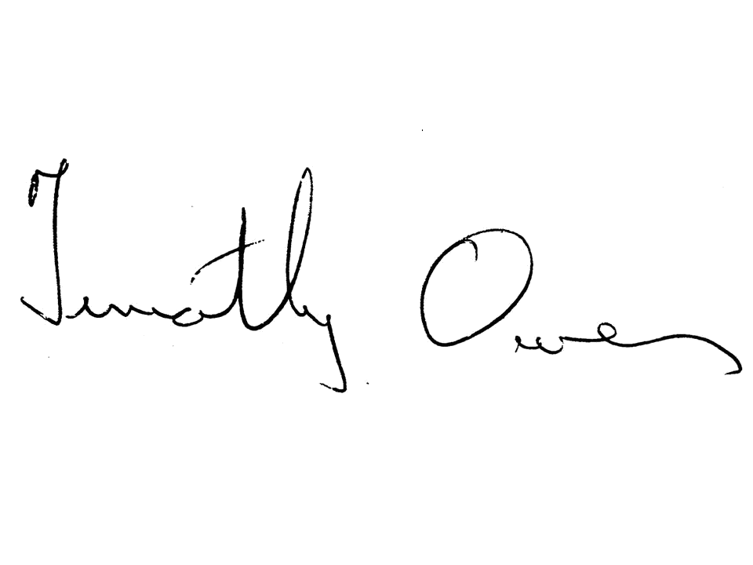

Signed: ________________________
TIMOTHY OWENS,
Chief Executive Officer.

Date: 01 May, 2012.

